**Individual Project 2 – Option 2:**

**Analysis for the PSU Retail District**

***Please submit your report in Word to*** [***freybote@pdx.edu***](mailto:freybote@pdx.edu) ***on or before 12/05/2024 at 11.59pm.***

***Please make sure the respective Word file has your name on it! Points will be deducted if your name is missing.***

**BACKGROUND**

In Winter 2025, Lindsey Morse, the Executive Director of the [Center for Retail Leadership](https://www.pdx.edu/business/center-retail-leadership) in the School of Business at PSU, will work with an MBA capstone team and PSU’s [Planning, Construction and Real Estate](https://www.pdx.edu/finance-administration/pcre) (PCRE) department on developing a retail strategy for PSU.

Currently, PSU doesn’t have a comprehensive strategy for its retail properties and is struggling to attract tenants due to the poor perception of downtown as well as a reduced number of students that regularly come to campus.

However, the [Portland City Council](https://www.kgw.com/article/news/local/portland-keller-auditoriam-psu-proposal/283-cdc0e243-e571-427b-a3bd-80e3181bb5a3) just approved the Keller Auditorium renovations as well as a new entertainment venue at PSU (310 SW Lincoln Street), which will create two entertainment-focused anchors north and south of PSU. Furthermore, the [PSU business accelerator](https://www.pdx.edu/accelerator/) is currently renovating a property on SW 5th and SW Lincoln (former Science Education Center) to become a food hub for foods start-ups and innovators.

PSU is currently developing placemaking strategies across campus such as a skate park on SW 4th and SW Lincoln and a dog park on SW Market and SW Park. Hereby, Montgomery Plaza along SW Montgomery represents the core of the PSU retail district.

Map 1 presents an overview of the PSU campus and different highlighted areas.

**Map 1**

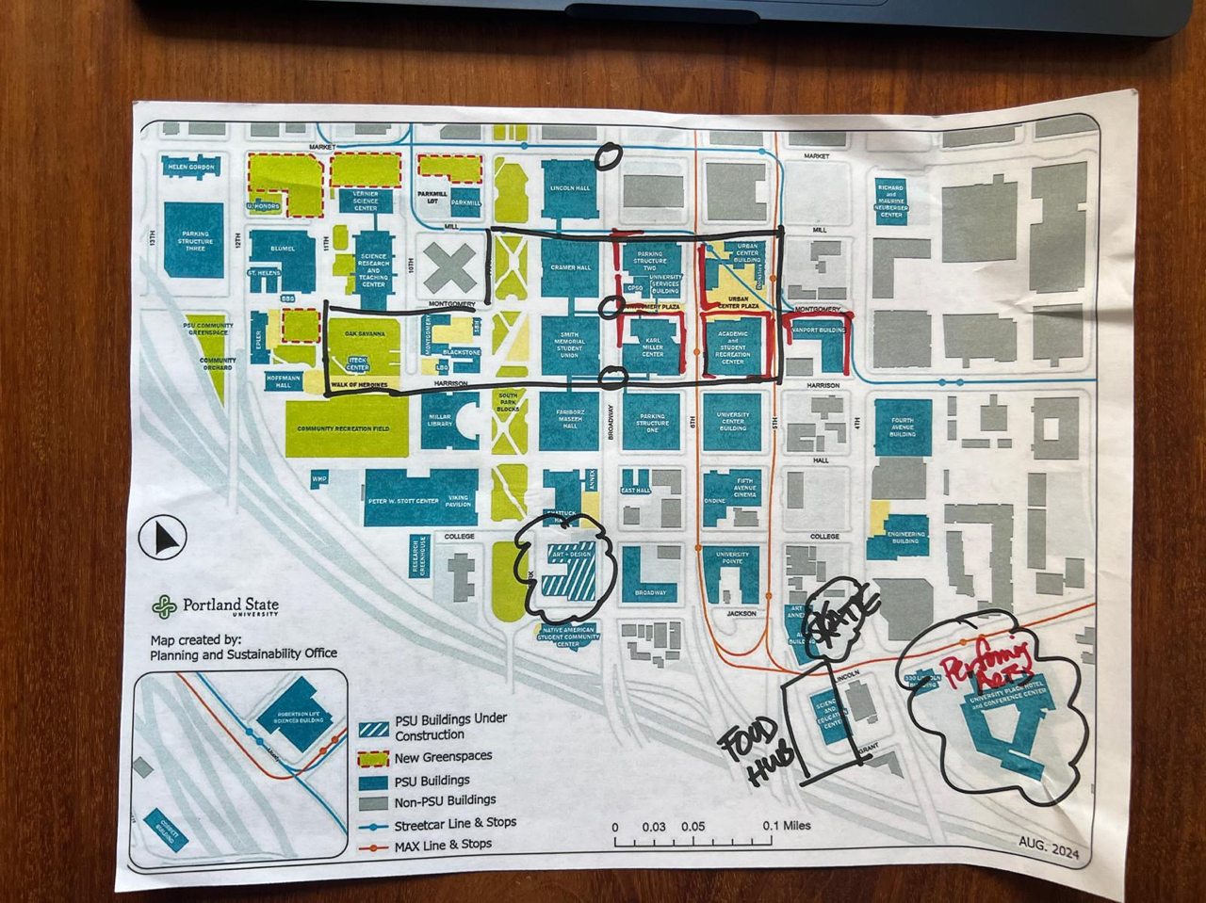

**YOUR TASK**

To help develop a retail strategy for PSU’s retail district (working title), you are tasked with using ArcGIS and any other source of data (optional) to analyze the following:

1. **Assess the characteristics of residents:**

Students, staff and faculty are not sufficient to generate required traffic for retailers. However, PSU is surrounded by apartment and condo buildings that can be used to activate the PSU retail district, particularly in the evening and on weekends.

To better understand the characteristics of residents in properties surrounding the PSU campus, conduct an analysis in ArcGIS for a 5-, 10- and 15-minute walk radius (trade area). Provide as much information on these residents as possible (e.g., income, demographics, ESRI profile, spending characteristics).

As crime and security concerns are commonly cited by retailers and visitors for the PSU campus and surrounding areas, also analyze crime data in ArcGIS for the trade area.

**Analytics, demographic and lifestyle maps use credits (10 per report). Maps, searching single addresses or places or exporting data don’t use any credits. When doing your analysis, please be sensitive to your remaining credits, use maps to get information whenever suitable and download reports selectively. Please make sure you regularly check on how many credits you have left.**

**If you need more credits, please let me know.**

1. **Assess the characteristics of daytime visitors**

Workers in offices surrounding PSU as well as tourists/visitors represent two other groups to support retail businesses on the PSU campus. Investigate whether ArcGIS has information to quantify office employment and tourism numbers for the trade area. What information is available for these two groups that can help develop a retail strategy for PSU?

1. **Assess retail business in the trade area:**

Analyze retail businesses in the trade area. What type of retailers exist? Are there differences between the ones that serve residents, tourists/visitors and office employees? Is there a void in the retail offerings considering the characteristics of residents? Is there a void in the retail offerings with regards to tourists and/or office employee?

Create one or multiple maps of different types of retail businesses in the trade area. You can either use ArcGIS maps or separately geocode existing retail businesses you identified and upload the information into ArcGIS or Tableau to spatially visualize the information. Use the [Census Geocoding tool](https://geocoding.geo.census.gov/geocoder/) (Find Locations -> One line or Batch address processing) to get the longitudes and latitudes for the identified retail businesses.

1. **Recommendations**

Based on your analysis, what are your recommendations for the overall PSU retail strategy and/or individual retailers/retail segments that should be approached about considering stores on campus? How could the PSU retail district differentiate itself from other areas such as the NW 23rd area/Slabtown, Pearl District or Pioneer Square? Your recommendations could also reflect your preferences as a student coming to campus and/or resident of downtown.

**DELIVERABLE**

Prepare a report for your client that presents the results of your analysis, your discussion and final recommendations. Your client is Lindsey and the PSU PCRE department.

Your report should have at least 10 pages (font: 12, spacing: 2pt), including executive summary (1 page), tables, pictures, and graphs.

Your final report should be written for your client (as opposed to an academic assignment) and highlight the findings of your analysis that are relevant to their objectives. To write your report, use the Tree of Thought (three experts) prompting approach in ChatGPT to get ideas on how to best present the results of your market analysis to your client. Pick the approach you like the most and ask ChatGPT for an outline of how to structure your report using the respective expert. Use your judgement on which parts of the ChatGPT recommended structure you want to follow and which you’ll ignore.

Decide which maps and tables to include in your report and make sure you refer to them in your text (e.g., “As shown in Map 1,…” or “…. (Map 1)”.)

Make sure your report is reader-friendly, professionally written, and free of typos and grammatical errors. Assume this is a report you submit to your client. If you want, you can even create a firm name and/or logo for yourself. Make sure your report has page numbers.